**PURBANCHAL UNIVERSITY**

**Biratnagar Nepal**



A Project report on

**“Exam Hall Seat Management System”**

In the partial fulfillment for the requirement of the 4rth Semester Project-IV (subject code- BIT256CO) in the completion of **Bachelor of Information Technology (BIT)** degree at **KIST college** **of Information Technology**, under **Purbanachal University.**

**Submitted By:- Submitted To:-**

1. **Kushal Pathak Purbanchal University**
2. **Pranam Rai**
3. **Upasana Khatiwada**

**Under The Guidance of**

**Mr. Roshan Shrestha**

**Lecturer, BIT**

**KIST COLLEGE OF INFORMATION AND TECHNOLOGY KAMALPOKHARI, KATHMANDU NEPAL**

**KIST COLLEGE OF INFORMATION AND TECHNOLOGY**

**KATHMANDU, NEPAL**

**CERTIFICATE**

This is to certify that the project work entitled **“EXAM HALL SEAT MANAGEMENT SYSTEM”** is carried out by **KUSHAL PATHANK (5398), PRANAM RAI (5415), UPASANA KHATIWADA (5425),** bona fide students of **KIST COLLEGE OF INFORMATION AND TECHNOLOGY** in partial fulfillment for the award of **BACHELOR IN INFORMATION AND TECHNOLOGY** of the **PURBANCHAL UNIVERSITY, BIRATNAGAR NEPAL**, during the year **2022-2023**. It is certified that all corrections indicatedfor internal assessment have been incorporated in the report submitted in the department library. The project report has been approved, as it satisfied the academic requirements in respect of the project work prescribed for the said degree.

The details of the students are as follows:-

**NAME REGISTRATION NO. SYMBOL NO.**

Kushal Pathak 058-3-2-04722-2020 345491

Pranam Rai 058-3-2-04729-2020 345497

Upasana Khatiwada 058-3-2-04750-2020 345515

Course Semester: - 4rth Semester

Subject: - Project-IV

Subject Code: - BIT256 CO

IMG_256

Mr. Deepak Khadka

Program Coordinator, BIT

**KIST COLLEGE OF INFORMATION AND TECHNOLOGY KAMALPOKHARI, KATHMANDU**

**Examiner’s Certification**

The Project Report

On

**“EXAM HALL SEAT MANAGEMENT SYSTEM”**

**Developed by**

**Kushal Pathak**

**Pranam Rai**

**Upasana Khatiwada**

Is approved and is acceptable in qualify form.

**Internal Examiner**

Name:

Designation:

**External Examiner**

Name:

Designation:



**ACKNOWLEDGEMENT**

It is with greatest satisfaction and euphoria that we are submitting our project report entitled **“EXAM HALL SEAT MANAGEMENT SYSTEM”.** We have completed it as a part of the curriculum of **PURBANCHAL UNIVERSITY.**

We also take this opportunity to express a deep sense of gratefulness to our **BIT Coordinator Mr.** **Deepak Khadka** and **BIT Lecturer Mr. Roshan Shrestha** for their amiable support, valuableinformation and guidance which helped us in completing this task throughout its various stages. We are indebted to all members of **KIST College,** for the valuable support and suggestion provided by them using their specific fields’ knowledge. We are grateful for their cooperation during the period of our project.

Finally we would also like to express our gratefulness towards **Purbanchal University** for designing such a wonderful course structure. It will help us to get more knowledge in the field of Information Technology & help us to have a bright future in the field of technology.

We hope our university will accept this attempt as a successful project.

Last but not the least, our sincere thanks to our parents, teaching and non-teaching staffs of our college and also my friends.

**KUSHAL PATHAK (345491)**

**PRANAM RAI (345497)**

**UPASANA KHATIWADA (345515)**

**STUDENT’S DECLARATION**

We hereby declare that the project report entitled “**EXAM HALL SEAT MANAGEMENT SYTEM**” is a result of our own work. If we are found guilty of copying any other report or published information and showing as our original work, we understand that we shall be liable and punishable by **Purbanchal University**.

 We further certify that this Project submitted in partial fulfillment of the requirement for the award of Bachelor in Information Technology (**BIT**) of the **Purbanchal University** is our original work and has not been submitted for award of any other degree or other similar title or prize.

|  |  |  |  |
| --- | --- | --- | --- |
| S.N. | Name | Registration No. | Symbol No. |
| 1 | Kushal Pathak | 058-3-2-04722-2020 | 345491 |
| 2 | Pranam Rai | 058-3-2-04729-2020 | 345497 |
| 3 | Upasana Khatiwada | 058-3-2-04750-2020 | 345515 |

**TO WHOM IT MAY CONCERN**

This is to certify that Mr. Kushal Pathak, Mr. Pranam Rai, Ms. Upasana Khatiwada pant of Bachelor in Information Technology (BIT) has studied as per the curriculum of BIT 4rth Semester and completed the project entitled “Exam Hall Management System**”**.This project is the original work of Mr. Kushal Pathak, Mr. Pranam Rai, Ms. Upasana Khatiwada and was carried out under the supervision of Mr. Roshan Shrestha as per the guidelines provided by Purbanchal University and certified as per the student’s declaration that project “**Exam Hall Management System**” has not been presented anywhere as a part of any other academic work.

The detail of the student is as follows:

Name of Students        :  Kushal Pathak

                                        Pranam Rai

                                        Upasana Khatiwada

Semester:   4th

Subject Code:   BIT256C0

Project Title:   **Exam Hall Seat Management System**

…………………………….

Mr. Deepak Khadka   
Program Coordinator, BIT   
KIST College of Information Technology

**ABSTRACT**

The Exam Hall Seat Management System is a comprehensive software solution

designed to streamline and automate the complex process of organizing and

managing seating arrangements for examinations in educational institutions.

The system offers a user-friendly interface that allows administrators to input various parameters, including the number of students, available exam halls, seating capacity of each hall, and any specific seating requirements or restrictions. Using this data, the system employs advanced algorithms to generate optimized seating plans, taking into account factors such as social distancing requirements and accessibility needs.

These plans are designed to minimize cheating opportunities and promote a fair examination environment. This system addresses the challenges faced by educational institutions in efficiently allocating seats, ensuring fairness, and maintaining security during exam periods.

**Table of Content**

[CHAPTER 1 1](#_Toc145798473)

[INTRODUCTION 1](#_Toc145798474)

[1.1 INTRODUCTION 1](#_Toc145798475)

[1.2 SIGNIFICANCE 2](#_Toc145798476)

[1.3 OBJECTIVES 3](#_Toc145798477)

[1.4 FEATURES 3](#_Toc145798478)

[1.5 TEAM STRUCTURE AND ROLE 4](#_Toc145798479)

[CHAPTER 2 5](#_Toc145798480)

[SYSTEM ANALYSIS 5](#_Toc145798481)

[2.1 LITERATURE REVIEW 5](#_Toc145798482)

[CHAPTER 3 6](#_Toc145798483)

[SYSTEM DESIGN 6](#_Toc145798484)

[3.1 WORKING PRINCIPLE 6](#_Toc145798485)

[3.2 ALGORITHM 6](#_Toc145798486)

[3.3 FLOW CHART 7](#_Toc145798487)

[3.4 GANTT CHART 10](#_Toc145798488)

[3.5 USE CASE DIAGRAM 12](#_Toc145798489)

[CHAPTER 4 13](#_Toc145798490)

[SYSTEM DEVELOPMENT AND IMPLEMENTATION 13](#_Toc145798491)

[4.1 SOFTWARE SPECIFICATIONS 13](#_Toc145798492)

[4.2 HARDWARE SPECIFICATIONS 13](#_Toc145798493)

[CHAPTER 5 14](#_Toc145798494)

[CONCLUSION 14](#_Toc145798495)

[5.1 CONCLUSION 14](#_Toc145798496)

[5.2 LIMITATIONS 14](#_Toc145798497)

[5.3 FUTURE ENHACEMENTS 15](#_Toc145798498)

[Chapter 6 17](#_Toc145798499)

[Screenshots 17](#_Toc145798500)

[REFERENCE 22](#_Toc145798501)

# CHAPTER 1

## INTRODUCTION

### INTRODUCTION

Education is the cornerstone of progress and development in any society, and examinations serve as a crucial measure of students' knowledge and skills. However, the logistical challenge of orchestrating these assessments is no small feat. Educational institutions, ranging from primary schools to universities, grapple with the intricate task of organizing exam hall seating arrangements. The Exam Hall Seat Management System, a cutting-edge technological solution, has emerged as the beacon of efficiency in the otherwise complex world of examination logistics.

At its core, the Exam Hall Seat Management System is a robust software platform designed to revolutionize the orchestration of seating arrangements for examinations. Leveraging sophisticated algorithms, real-time data processing capabilities, and extensive customization options, this system redefines how educational institutions manage this pivotal task.

Exam Hall Seat Management System lies in its ability to:

**Optimize Seat Allocation:** The system harnesses the power of intelligent algorithms to automate the often intricate process of assigning seats to students. It takes into account a myriad of variables, including the availability of exam halls, the seating capacity of each hall, student preferences, and institutional regulations.

**Enhance Fairness:** By ensuring that students are distributed across exam halls impartially, the system upholds the principles of fairness and neutrality, thereby eradicating the potential for cheating or favoritism during examinations.

**Boost Security:** The system serves as a formidable guardian of examination integrity. By minimizing opportunities for academic misconduct, it contributes to a secure examination environment where the authenticity of the assessment process is meticulously maintained.

**Accommodate Special Needs**: In its commitment to inclusivity, the system accommodates the unique requirements of students with disabilities, ensuring that they have the necessary seating arrangements to facilitate their active participation in exams.

**Provide Real-time Updates:** Administrative personnel can make on-the-fly adjustments to seating assignments and receive real-time updates, empowering institutions to respond swiftly to unforeseen developments.

**Generate Comprehensive Reports**: The system offers detailed reports and analytical insights that provide a deeper understanding of seating data. These reports empower institutions to fine-tune their strategies for future examinations, improving efficiency and fairness.

### SIGNIFICANCE

The Exam Hall Seat Management System holds significant importance in the realm of educational administration for several compelling reasons:

**Efficiency and Time Savings:** Perhaps the most immediate significance lies in its ability to streamline and automate a previously time-consuming and labor-intensive process. By automatically assigning seats, generating seating plans, and handling last-minute changes, the system drastically reduces the administrative burden on educational institutions. This efficiency allows administrators to allocate their time and resources more effectively.

**Fairness and Impartiality:** The system plays a pivotal role in promoting fairness and impartiality during examinations. By employing algorithms that ensure students are distributed across exam halls equitably, it eliminates the possibility of favoritism or bias in seat assignments. This contributes to the credibility and integrity of the examination process.

**Enhanced Security:** In an era where academic misconduct and cheating pose significant challenges, the system strengthens security measures. It minimizes opportunities for cheating by strategically placing students and monitoring seating arrangements. This proactive approach safeguards the authenticity of the assessment process.

**Accessibility and Inclusivity:** The system's ability to accommodate students with disabilities and specific needs demonstrates its commitment to inclusivity. It ensures that no student is disadvantaged due to physical limitations or unique requirements, fostering a more inclusive and equitable educational environment.

**Real-time Adaptability:** The system's real-time updates and flexibility enable educational institutions to respond promptly to unforeseen circumstances. Whether it's accommodating a sudden change in seating requirements or addressing emergencies, the system empowers administrators to make agile decisions.

**Data Analysis and Improvement**: The generation of comprehensive reports and analytics provides institutions with valuable insights into seating data and historical trends. This information allows for data-driven decision-making, enabling institutions to refine their seating allocation strategies and continuously improve the efficiency of future examinations.

**Reduced Errors and Discrepancies:** Human errors in manual seat allocation, such as double-bookings or misplaced students, can lead to administrative headaches and student dissatisfaction. The system minimizes such errors, enhancing overall organizational reliability.

**Scalability:** The system's versatility allows it to adapt to a wide range of examination scenarios, from small classroom tests to large-scale, high-stakes assessments. This scalability makes it a valuable tool for institutions of all sizes and levels.

**Cost Savings:** While the initial implementation of such a system may require an investment, the long-term cost savings are often substantial. Reduced administrative overhead, increased efficiency, and minimized errors can lead to cost-effective operations for educational institutions.

### OBJECTIVES

The objectives of an Exam Hall Seat Management System are to streamline the process of organizing and managing seating arrangements for examinations in educational institutions. These objectives are designed to improve efficiency, fairness, and security in the examination process. Here are the key objectives:

* To Optimize Seat Allocation.
* To Enhance Fairness.
* To Boost Security.
* To Reduce Administrative Burden.
* To Provide Real-time Updates.

### 

### 1.4 FEATURES

**1. User Authentication:**

Secure login and authentication for administrators, proctors, and students.

**2. User Roles:**

Different levels of access and permissions for administrators and students.

**3. Data Input and Management:**

Capability to input and manage student information, examination schedules, and hall capacities.

**4. Seat Allocation Algorithm:**

Efficient algorithm for automated seat allocation based on specified criteria.

**5. Fairness Criteria:**

Consideration of fairness criteria to prevent any student from having an unfair advantage.

**6. Security Measures:**

Security features to deter cheating and impersonation during exams.

**7. Accessibility Features:**

Accommodations for students with disabilities, including accessible seating arrangements.

**8. Real-Time Updates:**

Real-time monitoring and updates during seat allocation to address issues promptly.

**9. Reporting and Documentation:**

Generation of seating plans, student lists, and relevant documentation for proctors and administrators.

**10. Scalability:**

Ability to handle a large number of students and exams simultaneously.

### 1.5 TEAM STRUCTURE AND ROLE

The members assigned with these particular responsibilities:

|  |  |  |  |  |  |
| --- | --- | --- | --- | --- | --- |
| Members | Study and analysis | Designing | Coding  and hardware | Debugging | Documentation |
| Kushal Pathak | Kushal Pathak | Kushal Pathak | Kushal Pathak | Kushal  Pathak | Kushal  Pathak |
| Pranam  Rai | Pranam  Rai | Pranam  Rai | Pranam  Rai | Pranam  Rai | Pranam  Rai |
| Upasana Khatiwada | Upasana Khatiwada | Upasana Khatiwada | Upasana Khatiwada | Upasana Khatiwada | Upasana  Khatiwada |

# CHAPTER 2

## SYSTEM ANALYSIS

### 2.1 LITERATURE REVIEW

The development of exam hall seat management systems has been a critical response to the need for efficient, secure, and fair allocation of seats during academic examinations. This area of research and implementation has evolved significantly over time, with an emphasis on optimizing algorithms and techniques for seat allocation. Existing literature highlights various optimization algorithms, heuristic methods, and mathematical models employed to tackle the complex task of seat assignment.

Additionally, the integration of software solutions tailored for seat management has gained prominence, with an emphasis on features, usability, and scalability. Security and fairness remain paramount concerns, with strategies devised to combat cheating and bias in seat assignments. Moreover, user experience, accessibility, and seamless integration with student information systems have been central to the successful deployment of these systems in educational institutions. Real-world case studies shed light on the practical challenges faced, along with valuable lessons learned. As technology advances, considerations like IOT devices and mobile applications have started influencing the field. Ethical and legal compliance, including data privacy and student rights, are integral aspects. To improve system effectiveness, user feedback and satisfaction have been instrumental, contributing to system enhancements. Comparative analyses offer insights into the strengths and weaknesses of various systems, aiding institutions in making informed choices.

# CHAPTER 3

# SYSTEM DESIGN

### 3.1 WORKING PRINCIPLE

The exam hall seat management system operates on the fundamental principle of efficiently allocating seats to students for academic examinations. At its core, the system collects and processes essential data, including student information, examination schedules, and available seating capacities within exam halls. Leveraging specialized seat allocation algorithms, the system intelligently assigns seats to students while adhering to predefined criteria. These criteria encompass fairness, security, and accessibility, ensuring that no student gains an unfair advantage that measures are in place to prevent academic dishonesty, and that accommodations are made for students with special needs.

Throughout the allocation process, real-time updates allow administrators to monitor and adjust seating arrangements as needed. Furthermore, the system provides reporting and documentation to facilitate exam proctors and administrators' tasks.

Seamless integration with the institution's Student Information System (SIS) ensures data consistency and accuracy, while user-friendly interfaces empower both administrators and students to interact with the system efficiently. Data security and privacy are paramount, safeguarding sensitive information, and ensuring compliance with relevant regulations. In essence, the exam hall seat management system streamlines the complex task of seat allocation, contributing to a fair, secure, and well-organized examination process in educational institutions.

### 3.2 ALGORITHM

Algorithm for Exam Seat Plan Management System in Java:

1. Initializing the system with the number of exam seats and other necessary parameters.

2. Creating a data structure to represent students, including attributes like name, student ID, etc.

3. Creating a data structure to represent exam seats, including attributes like seat number and occupant (initially null).

4. Creating a data structure for the seat plan, which contains an array or list of exam seats.

5. Implementing a function to assign a student to an available seat:

- Iterate through the list of exam seats.

- Checking if the seat is vacant (occupant is null).

- If a vacant seat is found, assign the student to that seat.

- If no vacant seats are available, moving for the next room or the next exam hall.

6. Implementing a function to display the current seat plan:

- Iterate through the list of exam seats.

- For each seat, check if it is occupied or vacant.

- If occupied, displaying the seat number and the student's details (student ID , semester).

7. Implementing additional features as needed, such as:

- Removing a exam hall and exam room.

- Searching for a student by Student ID.

- Handling different exam halls or rooms.

-Printing the seat plan

8. Creating a user interface (UI) to interact with the seat plan management system, allowing users to input commands and view the seat plan.

9. Implementing error handling to handle cases like invalid seat numbers or students not found.

10. Testing the system thoroughly to ensure it works as expected.

### 3.3 FLOW CHART

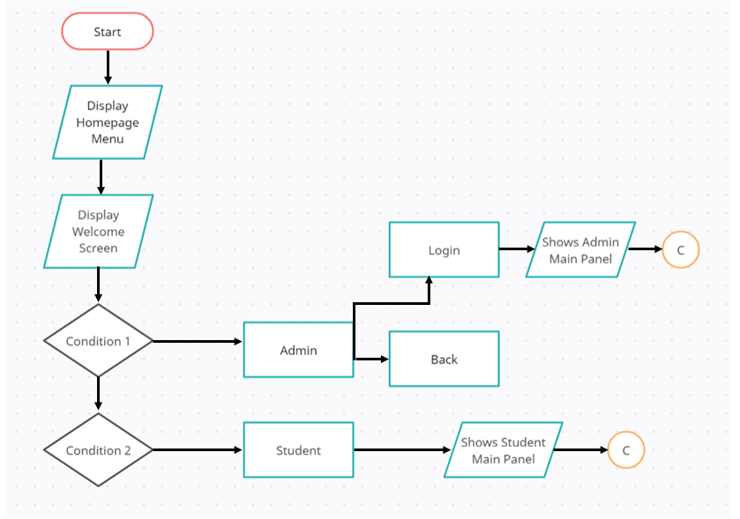

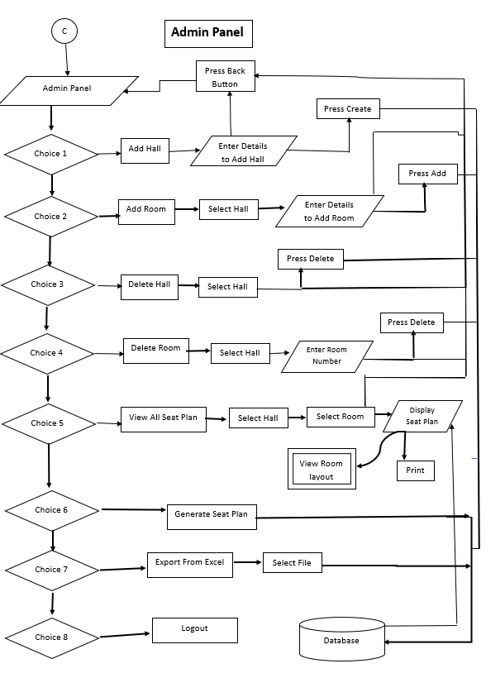

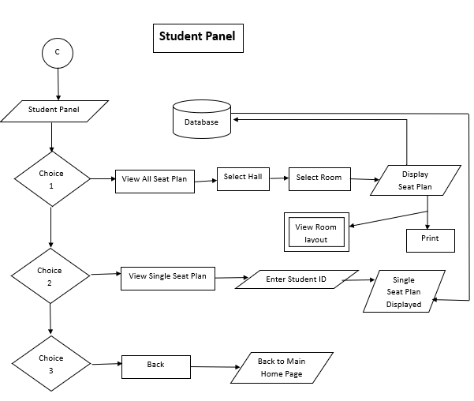

### 3.4 GANTT CHART

|  |  |  |
| --- | --- | --- |
|  |  |  |
|  |  |  |
| **Tasks** | **Duration** | **Start Date** |
| Project Planning | 7 days | 7-Aug-23 |
| Requirement Analysis | 5 days | 14-Aug-23 |
| Database Design | 7 days | 15-Aug-23 |
| Backend Development | 15 days | 16-Aug-23 |
| Frontend Development | 9 days | 17-Aug-23 |
| QA and Testing | 5 days | 18-Aug-23 |
| Deployment and Release | 2 days | 19-Aug-23 |
|  |  |  |

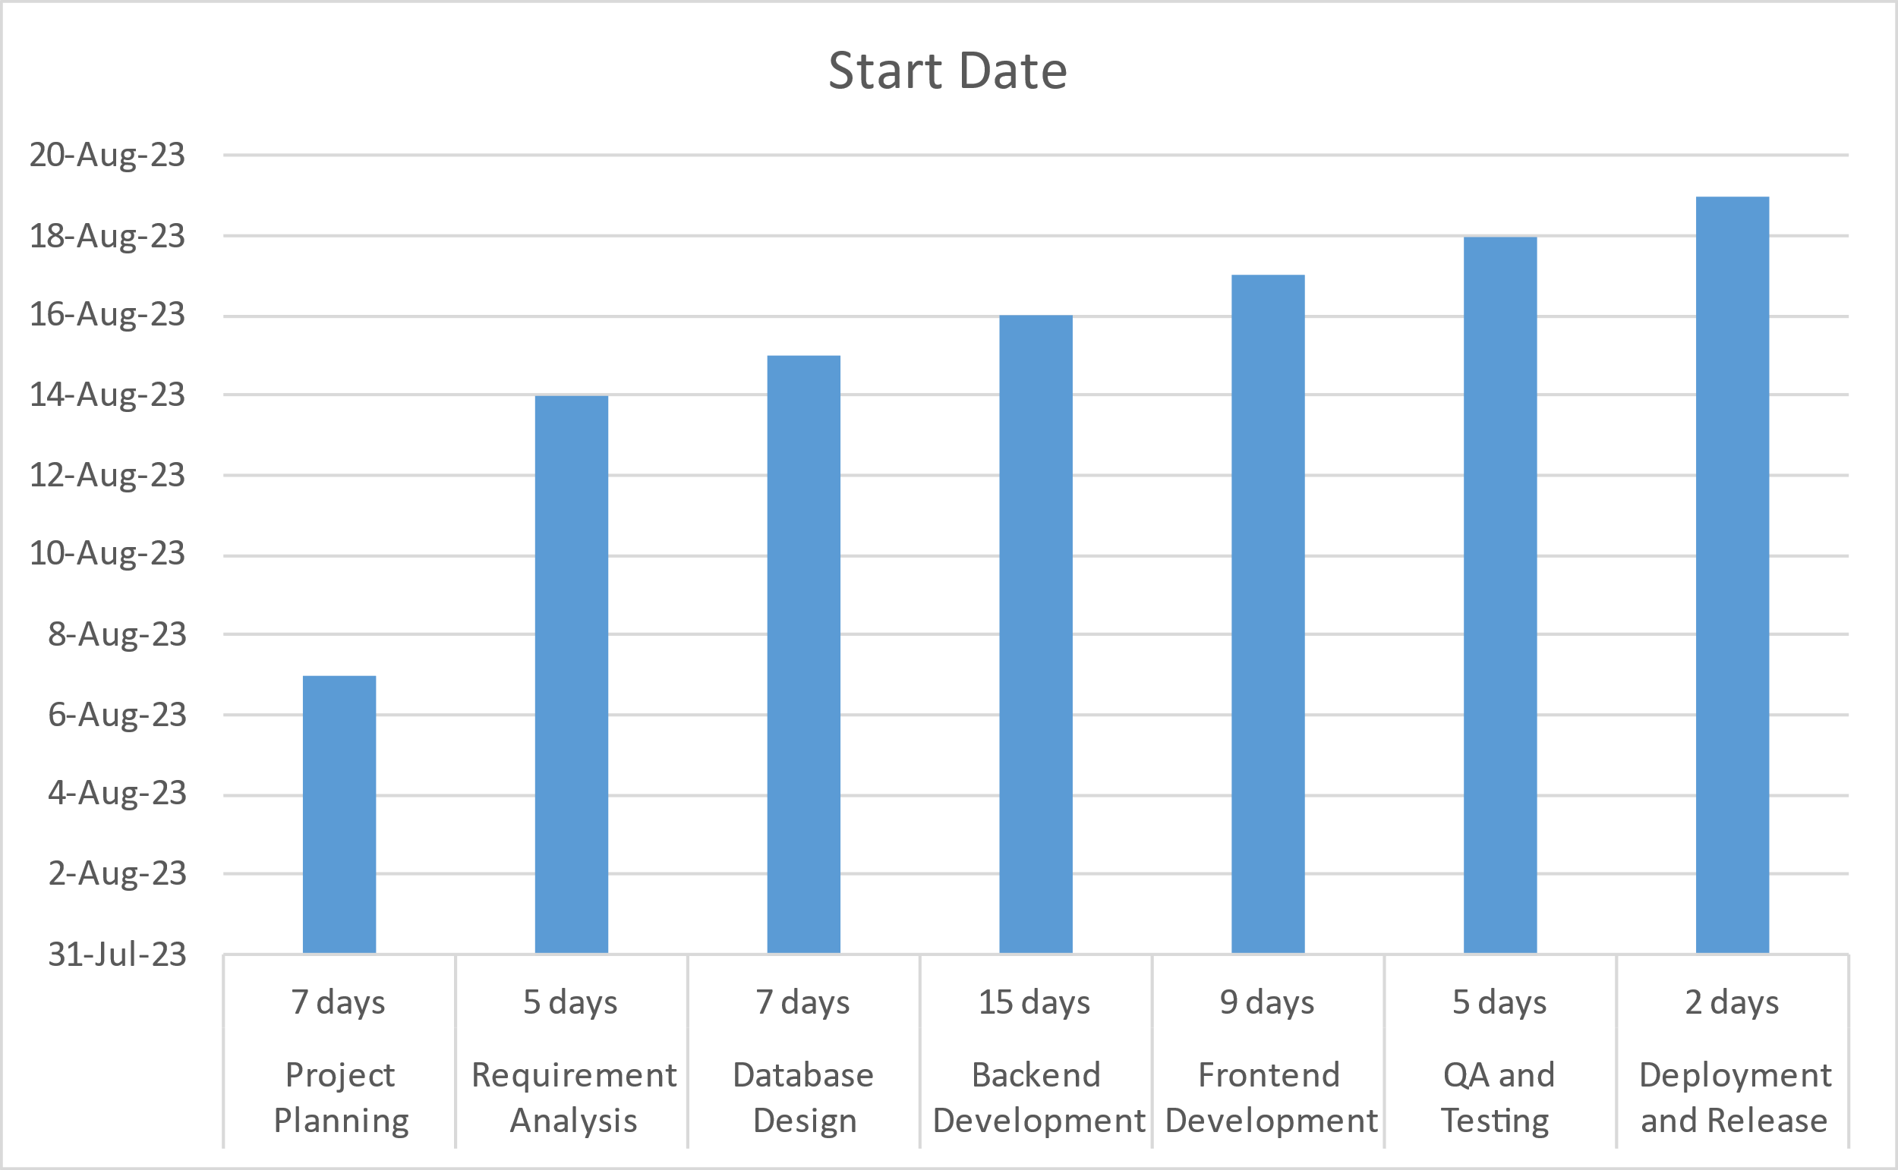

### 3.5 USE CASE DIAGRAM

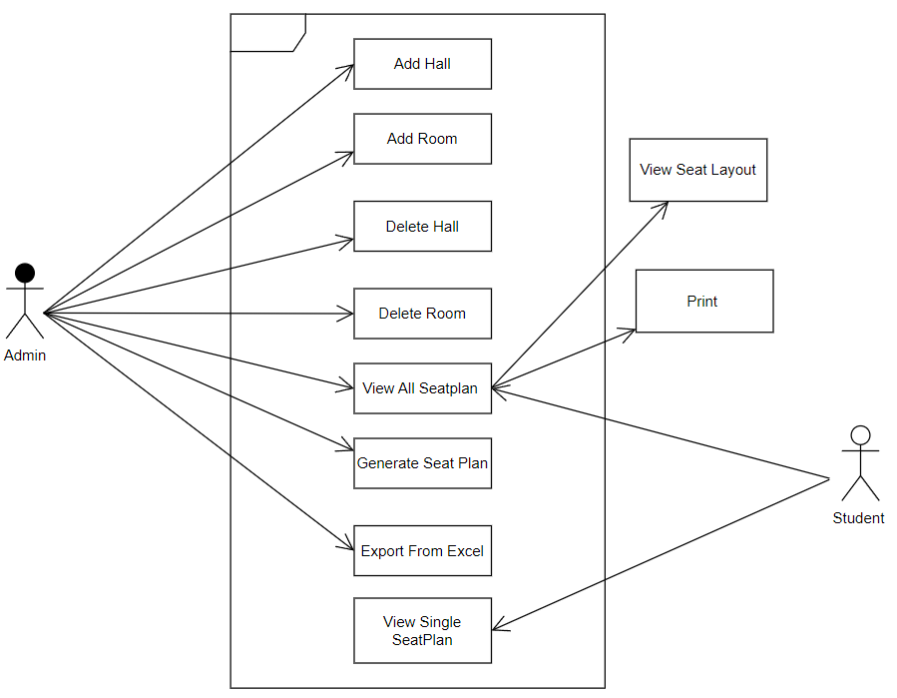

# CHAPTER 4

# SYSTEM DEVELOPMENT AND IMPLEMENTATION

### 4.1 SOFTWARE SPECIFICATIONS

Computer software specification we have used for development:

* Operating System: Windows 10 Operating System or above
* IntelliJ IDEA
* Visual Studio

### 4.2 HARDWARE SPECIFICATIONS

Computer hardware specification we have used for development:

* Processor: Intel Core i5
* RAM: 8GB
* SSD: 224GB

# CHAPTER 5

## CONCLUSION

### 5.1 CONCLUSION

In conclusion, an exam hall seat management system is a valuable tool for educational institutions and examination authorities to streamline the organization of exams, enhance security, and improve the overall experience for candidates and administrators. It offers numerous benefits, including efficient seat allocation, reduced administrative workload, and increased transparency in the exam process.

However, it is important to recognize that while these systems offer significant advantages, they also come with their share of limitations and challenges. Technical issues, scalability concerns, data security and privacy issues, user adoption hurdles, and the need for ongoing maintenance and training are all factors that must be carefully considered when implementing such a system.

To make the most of an exam hall seat management system, educational institutions should prioritize user training, data security measures, and adaptability to evolving needs. Regular evaluations and updates are essential to address limitations and ensure that the system remains effective and efficient.

### 5.2 LIMITATIONS

Exam hall seat management systems have several limitations, and it's important to be aware of these challenges when designing and implementing such systems. Here are some common limitations:

1. **System Downtime:** The system may experience technical issues or downtime, which can disrupt exam scheduling and cause inconvenience to both candidates and administrators.
2. **Data Entry Errors:** Human errors during data entry can lead to inaccuracies in seating arrangements and candidate information.
3. **Compatibility Problems:** Compatibility issues may arise when integrating the system with various hardware and software configurations used by different exam centers.
4. **Limited Scalability:** This seat management systems may struggle to scale effectively, particularly when dealing with a large number of candidates or multiple exam centers.
5. **Data Breaches:** Security breaches can expose sensitive candidate information, which can be damaging to individuals and institutions.
6. **Privacy Concerns:** Candidates may have concerns about their personal data and exam results being stored in the system.
7. **User Resistance:** Users (administrators, exam coordinators, candidates) may resist using new technology, leading to challenges in adoption.
8. **Dependence on Hardware:** The availability and condition of hardware (computers, tablets, etc.) at exam centers can impact the system's usability.
9. **Device Failures:** Hardware failures during exams can disrupt the testing process.
10. **Cheating and Security Concerns:** While the system can enhance security, determined cheaters may still find ways to circumvent it. Proactive measures are needed to prevent cheating.

### FUTURE ENHACEMENTS

The future enhancement of an exam hall seat management system should focus on improving efficiency, security, and user experience. Here are some potential enhancements:

1. **Biometric Authentication**: Implement biometric authentication (such as fingerprint or facial recognition) to ensure that the registered candidates are the ones taking the exam. This enhances security and prevents impersonation.

2. **AI Surveillance**: Integrate AI-powered surveillance cameras to monitor exam halls in real-time. These cameras can detect suspicious behavior, cheating, or unauthorized electronic devices.

3. **Block-chain Technology:** Use block-chain for secure and tamper-proof record-keeping of exam data, including seating arrangements, candidate information, and exam results.

4. **Predictive Analytics:** Utilize predictive analytics to optimize seating arrangements based on candidate behavior and historical data. This can help reduce the likelihood of cheating and improve fairness in seating allocation.

5. **Smart Seating Algorithms:** Develop advanced seating allocation algorithms that take into account factors like candidate disabilities, special accommodations, and social distancing requirements (relevant in the context of COVID-19 or other health crises).

5. **Mobile App Integration:** Create a mobile app for candidates that provides real-time updates on their exam schedules, seating arrangements, and any changes. This can also include directions to the exam center.

6. **Real-time Updates:** Implement a real-time update system that allows exam coordinators to make immediate changes to seating arrangements in case of emergencies or last-minute adjustments.

7. **Data Analytics Dashboard**: Provide administrators with a comprehensive data analytics dashboard that offers insights into exam hall utilization, candidate performance trends, and any irregularities in the exam process.

8. **Integration with Student Management Systems:** Seamlessly integrate with student management systems used by educational institutions to automate the registration process and ensure accurate candidate information.

# Chapter 6

## Screenshots

6.1 Screenshots

**FirstScreen** **Welcome Screen**

Admin login Form Admin Section

Student Section Add Hall

Add Room Delete Hall

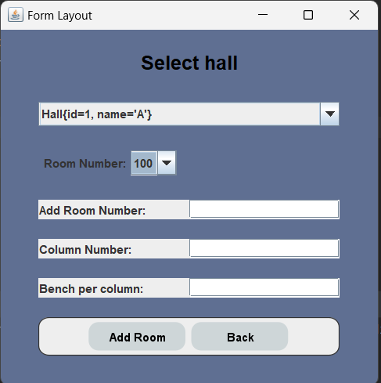

Delete Room Generate Seat Plan

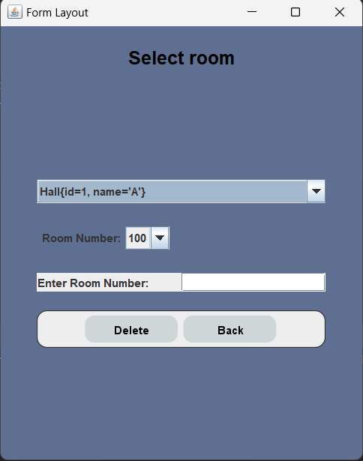

**View All Seat Plan** (Admin and Student panel -- no print option from Student View)

Step 1 Step 2

**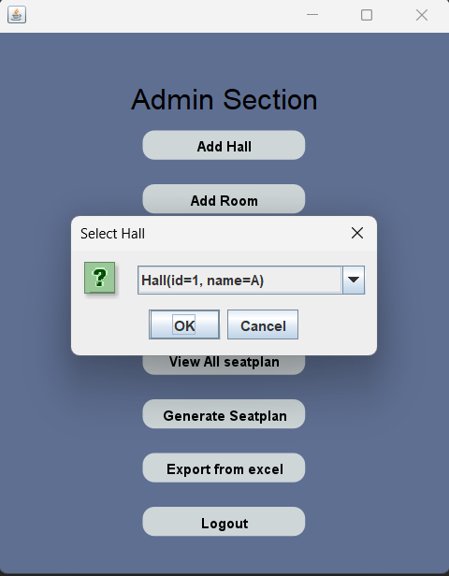**

Step 3

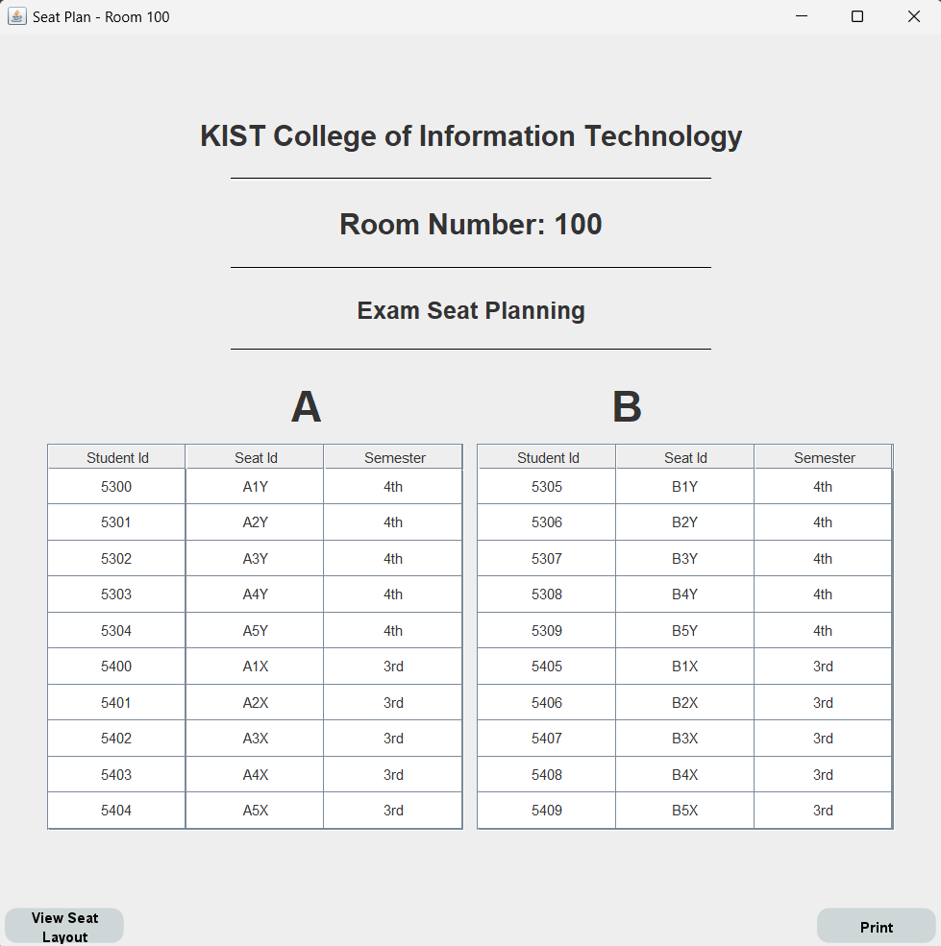

View Seat Layout

Export From Excel

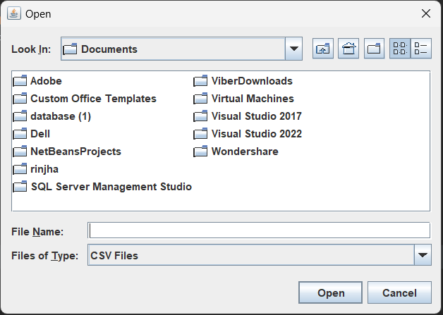

Single Seat Plan

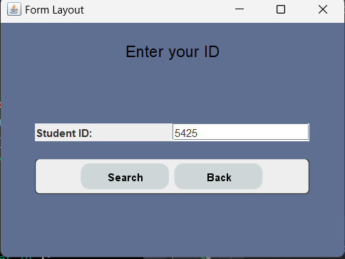

# REFERENCE

* <https://myprojectideas.com/exam-seating-management-system-in-java>
* https://www.freeprojectz.com/projects/exam-seating-arrangement-system